01. Neural Network

- Introduction

Neural network can have the following types:
- Standard NN, or fully connected NN
- Convolutional NN
- Recurrent NN

The input of neural networks can be categorized into two types:
- Structured data, such as given the size, number of bedrooms, locations, to predict the price of a house.
- Unstructured data, such as audio (speech reorganization), image (auto driving), and text (machine translation).

Given a training set $\left\{\left(x^{(1)},{ y}^{(1)}\right), …, \left(x^{(m)},{ y}^{(m)}\right)\right\}$, we use the following $X$ and $y$ to present a neural network.
$$X=\left[\begin{matrix}\begin{matrix}\begin{matrix}⋮ \\ x^{\left(1\right)} \\ ⋮\end{matrix} & \begin{matrix}⋮ \\ x^{\left(2\right)} \\ ⋮\end{matrix}\end{matrix} & \begin{matrix}\begin{matrix}⋮ \\ ⋯ \\ ⋮\end{matrix} & \begin{matrix}⋮ \\ x^{\left(m\right)} \\ ⋮\end{matrix}\end{matrix}\end{matrix}\right] y=\left[\begin{matrix}\begin{matrix}y^{(1)} & y^{(2)}\end{matrix} & \begin{matrix}⋯ & y^{(m)}\end{matrix}\end{matrix}\right]$$

- Logistic Regression

The following shows the sigmoid function $σ$ (i.e. $g$).
$$σ\left(z\right)= \frac{1}{1+e^{-z}}$$

The following shows the prediction (read y hat).
$$\hat{y}=σ\left(w^{T}x+b\right) (here, θ_{0}=b, θ_{1\sim n}=w)$$

The following shows the loss function (error function).
$$L\left(\hat{y}, y\right)=-\left(y∙\log{\hat{y}}+(1-y)∙\log{(1-\hat{y})}\right)$$

The following shows the cost function.
$$J\left(w,b\right)=\frac{1}{m}\sum_{i=1}^{m}{L({\hat{y}}^{(i)},y^{(i)})}=-\frac{1}{m}\sum_{i=1}^{m}{\left[y^{(i)}∙\log{{\hat{y}}^{(i)}}+(1-y^{\left(i\right)})∙\log{(1-{\hat{y}}^{\left(i\right)})}\right]}$$

The following shows the gradient descent.
$$dw≔\frac{dJ\left(w,b\right)}{dw}=\frac{1}{m}\sum_{i=1}^{m}{\left({\hat{y}}^{\left(i\right)}-y\right)∙x^{(i)}}$$
$$db≔\frac{dJ\left(w,b\right)}{db}=\frac{1}{m}\sum_{i=1}^{m}{\left({\hat{y}}^{\left(i\right)}-y\right)}$$
$$w≔w-α∙dw$$
$$b≔b-α∙db$$

The following shows the logistic regression on m examples.
- Set $J=0, dw_{j}=0 (j=1, 2,…, n), db=0$
- For $i=1$ to $m$ (number of examples)
$$z^{(i)}=w^{T}x^{(i)}+b$$
$$a^{(i)}={σ(z}^{(i)})$$
$$J +=-\left(y^{(i)}∙\log{a^{(i)}}+(1-y^{(i)})∙\log{(1-a^{(i)})}\right)$$
$$dz^{(i)}=a^{(i)}-y^{(i)}$$
For $j=1$ to $n$ (number of features)
$$dw_{j} += x_{j}^{(i)}∙dz^{(i)}$$
$${db +=dz}^{(i)}$$
- $J=J/m$
$$dw_{j}=dw_{j}/m (j=1, 2,…, n)$$
$$db=db/m$$
- $w_{j}=w_{j}- α∙{dw}_{j} \left(j=1, 2,…, n\right)$
$$b=b-α∙db$$

You may need to compute gradient descent multiple times. The following shows a vectorized version:

for i in range(1000):
z = w.T * X + b
a = sigmoid(z)
J = -(y * log(a).T + (1 - y) * log(1 - a).T) / m

dz = a – y
dw = X * dz.T / m
db = dz.sum() / m

w -= lambda * dw
b -= lambda * db

- Neural Network

The following shows how to compute the hidden layer parameters of a 2-layer neural network on one example.

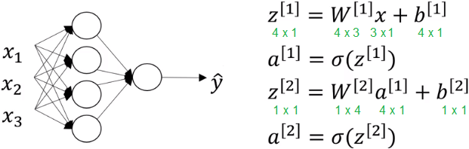

The following shows how to compute the output of the neural network on all m examples (forward propagation).

Z1 = W1 * X + b1
A1 = sigmoid(Z1)

Z2 = W2 * A1 + b2
A2 = sigmoid(Z2)

J = -(y * log(A2).T + (1 – y) * log(1 – A2).T) / m

# generic form:
Z[l] = W[l] * A[l-1] + b[l]
A[l] = sigmoid(Z[l])

- Activation Function

The following shows some activation functions. You can use different activation functions on different layers. The sigmoid function is usually used when the output is binary, i.e. 0 or 1.

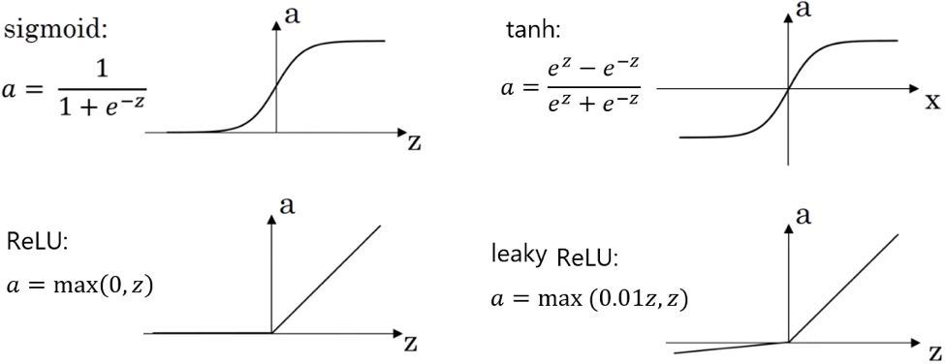

The following shows the $g^{'}\left(z\right)=\frac{d}{dz}g(z)$ function for different activation functions.

Function | $$g^{'}\left(z\right)$$
Sigmoid function | $$a(1-a)$$
Tanh function | $$1-a^{2}$$
ReLU function | $$\left\{\begin{aligned} 1 if z≥0 \\ 0 if z<0\end{aligned}\right.$$
Leaky ReLU function | $$\left\{\begin{aligned} 1 if z≥0 \\ 0.01 if z<0\end{aligned}\right.$$

- Backpropagation

The following shows the backpropagation algorithm using vectorization.
$$dz^{[L]}=a^{[L]}-y$$
$$…$$
$dZ^{[l]}=dA^{\left[l\right]} .* g^{'}(Z^{[l]})$ $dz^{[l]}=da^{\left[l\right]} .* g^{'}(z^{[l]})$
$$dW^{[l]}=\frac{1}{m}\left(dZ^{\left[l\right]}*{A^{[l-1]}}^{T}\right) dW^{[l]}=dz^{\left[l\right]}*a^{[l-1]}$$
$$db^{[l]}=\frac{1}{m}\sum_{i=1}^{m}{dZ^{[l](i)}} db^{[l]}=dz^{[l]}$$
$$dA^{[l-1]}={W^{[l]}}^{T}*dZ^{\left[l\right]} da^{[l-1]}=W^{[l]}*dz^{\left[l\right]}$$
$$…$$

The following shows how to implement it in Python.

dZ[l] = dA[l] .* g[l]'(Z[l])
dW[l] = dZ[l] * A[l-1].T / m
db[l] = np.sum(dZ[l], axis = 1, keepdims = True) / m

dA[l-1] = W[l].T * dZ[l]

The following shows how to compute 2-layer neural network.

dZ2 = A2 – y
dW2 = dZ2 * A1.T / m
db2 = np.sum(dZ2, axis = 1, keepdims = True) / m
dA1 = W2.T * dZ2

dZ1 = dA1 .* g1'(Z1)
dW1 = dZ1 * X.T / m
db1 = np.sum(dZ1, axis = 1, keepdims = True) / m

- Random Initialization

If the initial values of W's are all 0's, it will cause symmetric problem, i.e. all the activation units have the same output. Therefore, we need to initialize W's to some small values. If their values are large, it will cause the learning too slow. By the way, initializing the values of b's to 0 is OK.

W1 = np.random.randn((4, 3)) * 0.01 # 3 -> 4
b1 = np.zeros((4, 1))

W2 = np.random.randn((1, 4)) * 0.01 # 4 -> 1
b2 = np.zeros((1, 1))

Deep neural networks may have data vanishing or exploding gradients problem, which means that the derivatives can sometimes get either very big or very small exponentially, which makes training difficult. A partial solution does not solve this problem entirely but helps a lot, is to choose random initialization. For ReLU function, you can multiply the random numbers by $\sqrt{2 / L_{input}}$. For different activation functions, the variable can be different.

W1 = np.random.randn((4, 3)) * np.sqrt(2 / 3) # 3 -> 4
b1 = np.zeros((4, 1))

W2 = np.random.randn((1, 4)) * np.sqrt(2 / 4) # 4 -> 1
b2 = np.zeros((1, 1))

- Bias and Variance

Assume that the optimal error (base error) is 0%, if the training set error is high (such as 15%), we say that the learning algorithm has high bias. If there is a big growth from the training set error to the dev set error (such as from 1% to 12%), we say that the learning algorithm has high variance.

Training set error | 1% | 15% | 15% | 0.5%
Dev set error | 12% | 16% | 30% | 1%
Result | High variance | High bias | High bias  High variance | Low bias  Low variance

The training set, dev (cross-validation) set, and test set are usually 60%, 20%, 20%. For a large dataset (such as 1,000,000), the proportion can be different, such as 99.5%, 0.4%, 0.1%. The rule of thumb is that dev and test sets must come from the same distribution. Sometimes, not having the test set might be OK.

The following shows some ways to fix high variance.
- Regularization.
- Add more training examples, such as flipping the current training examples to double the training set.
- Early stopping. You can stop the training before the dev set error goes up.

- L2 Regularization

For logistic regression, the cost function with regularization is:
$$J\left(w, b\right)=\frac{1}{m}∙\sum_{i=1}^{m}{L\left({\hat{y}}^{(i)}, y^{(i)}\right)}+\frac{λ}{2m}∙\sum_{l=1}^{L}{w_{l}^{2}}$$

For neural network, the cost function with regularization is:
$$J\left(w^{[1]},b^{[1]},…, w^{\left[L\right]},b^{[L]}\right)=\frac{1}{m}∙\sum_{i=1}^{m}{L\left({\hat{y}}^{(i)}, y^{(i)}\right)}+\frac{λ}{2m}∙\sum_{l=1}^{L}{\sum_{i=1}^{l}{\sum_{j=1}^{l-1}{{\left(w_{i,j}^{[l]}\right)}^{2}}}}$$

The gradient descent with regularization is:
$$dW^{[l]}=\frac{1}{m}∙(dZ^{\left[l\right]}* A^{\left[l-1\right]}.T)+\frac{λ}{m}∙W^{[l]}$$

- Dropout Regularization

For each hidden layer (not input and output layers), we drop some hidden units randomly. The parameter keep_prob specifies the probability to keep the hidden units, for example, 0.8 means we want to keep 80% hidden units and drop 20% of them. First define a Boolean vector which has the same shape as $a^{\left[l\right]}$.
$$d^{[l]}=np.random.randn\left(a^{\left[l\right]}.shape\left[0\right], a^{\left[l\right]}.shape\left[1\right]\right)<keep_prob$$
$$a^{[l]}=a^{[l]} .*d^{[l]}$$
$a^{[l]}=a^{[l]} / keep_prob$ - this is because $a^{[l]}$ was reduced by keep_prob, and here add it back

Z1 = np.dot(W1, X) + b1
A1 = relu(Z1)

D1 = np.random.rand(A1.shape[0], A1.shape[1])
D1 = (D1 < keep_prob).astype(int)
A1 = A1 * D1
A1 = A1 / keep_prob

Z2 = np.dot(W2, A1) + b2
A3 = sigmoid(Z2)

In backpropagation, you need to shut down the same neurons by applying the same mask D1 to dA1, and then divide dA1 by keep_prob again.

dA1 = dA1 * D1
dA1 = dA1 / keep_prob

Remember, L2 regularization or dropout regularization should be applied to the training set only. Different layers can have different keep_prob values. If you don't want to drop any node on some layer, you can just set keep_prob to 1. The downside of dropout regularization is that the cost function $J$ is not well-defined.

- Gradient Checking

Gradient checking is only for debugging and does not work with dropout. For each example $i$:
$$d{θ_{approx}}^{[i]}=\frac{J\left(θ_{1}, …, θ_{i}+ϵ,…,θ_{n}\right)-J(θ_{1}, …, θ_{i}-ϵ,…,θ_{n})}{2ϵ}≈dθ^{[i]}$$

Then check:
$$\frac{\left\|{dθ}_{approx}-dθ\right\|}{\left\|{dθ}_{approx}\right\|+\left\|dθ\right\|}≈{10}^{-7}$$

Suppose that you need to compute $W1, b1, W2, b2$ in forward propagation, and compute $dW1, db1, dW2, db2$ in backpropagation.
$$d{W1}_{approx}=\frac{forward\left(W1+ϵ, b1, W2, b2\right)-forward\left(W1-ϵ, b1, W2, b2\right)}{2ϵ}$$
$$d{b1}_{approx}=\frac{forward\left(W1, b1+ϵ, W2, b2\right)-forward\left(W1, b1-ϵ, W2, b2\right)}{2ϵ}$$
…
$$dW1, db2, dW2, db2=backpropagation(…)$$

Now you can compare $d{W1}_{approx}$ and $dW1$ (and also other parameters) as below.

numerator = np.linalg.norm(dW1approx – dW1)
denominator = np.linalg.norm(dW1approx) + np.linalg.norm(dW1)
difference = numerator / denominator

if difference < 1e-7:
print("dW1 is correct")

You can also put all the gradients in a vector and compute them together.

gradapprox = [dW1approx, db1approx, dW2approx, db2approx]
grad = [dW1, db1, dW2, db2]

numerator = np.linalg.norm(gradapprox – grad)
denominator = np.linalg.norm(gradapprox) + np.linalg.norm(grad)
difference = numerator / denominator

- Normalization

Gradient descent converges faster after normalization.
$$\left\|x\right\|=sqrt\left(\sum_{i=1}^{n}{{x_{i}}^{2}}\right)$$

The following shows how to normalize $x$.
$$x=\left[ \begin{matrix}0 & 3 & 4 \\ 2 & 6 & 4\end{matrix} \right]$$
$$x_{normalized}=\frac{x}{\left\|x\right\|}=\left[ \begin{matrix}0 & 3/5 & 4/5 \\ 2/\sqrt{56} & 6/\sqrt{56} & 4/\sqrt{56}\end{matrix} \right]$$

